H.I. Seyed Hadi Yassin, CPC, MA
Life Coaching at SABA Health Center
Beginning April 19th, Every Saturday
SABA Center, Suite 21 (rental section)

We will provide services in three areas:
- Parenting
- Relationships (Marriage Conflict Resolution)
- Child Development

To schedule an appointment, call our direct line:
408-444-3139
**If you would like your name to remain confidential, you may schedule an appointment with a nickname via texting.

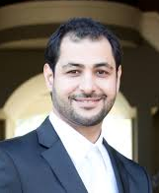
- Thirteen years of Howza studies, Mashhad, Iran
- MA in psychology from CSUSB, CA
- Active member of American Counseling Association
- Certified Professional Couch (CPC)
- Founding editor of Psychology Student Research Journal (PSRJ)

Office location and website:
2030 East 4th St., Suite 208,
Santa Ana, CA 92705
www.seyedhadiyassin.com

